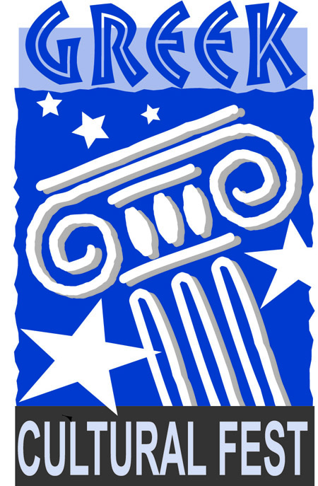
2013 Greek Cultural Festival

Sponsorship Program

Friday, June 14th and Saturday, June 15th

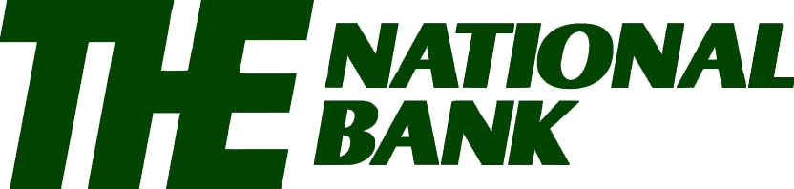

Please join the 2013 Presenting Sponsor

In sponsoring this year’s Greek Cultural Festival.

Gold Event Sponsor
Gift of $2500
Sponsor will receive:
20 Person VIP Tent² *New for 2013*
$625 in Food Coupons¹
500 Admission Tickets with your business logo ($1000 Value)
20 Wine Tasting Tickets ($400 Value)
Name and Logo on Sponsor Banner
Full Page in Festival Book
Silver Event Sponsor
Gift of $1000
Sponsor will receive:
$250 in Food Coupons¹
200 Admission Tickets with your business logo ($400 Value)
10 Wine Tasting Tickets ($200 Value)
Name and Logo on Sponsor Banner
Half Page in Festival Book

Bronze Event Sponsor
Gift of $500
Sponsor will receive:
$125 in Food Coupons¹
100 Admission Tickets ($200 Value)
4 Wine Tasting Tickets ($80 Value)
Quarter Page in Festival Book

Business Sponsor
Gift of $250
Sponsor will receive:
$50 in Food Coupons¹
75 Admission Tickets ($150 Value)
2 Wine Tasting Tickets ($40 Value)
Name listed in Sponsor Book

¹ Food Coupons are redeemable for 1 Food or Beverage Item up to $5 from the Outdoor Tent Area (excluding Pastries).
² Each Gold Sponsor will have their own VIP Tent which will include limited beverages and hors d’oeuvres for 2 hours each Day during primetime (7:00 p.m. - 9:00 p.m.) reserved with seating.
The Quad Cities’ taste of Greek traditions & culture

4900 Kennedy Drive
East Moline
Illinois 61244
309-792-2912

